
Activity based
Project Report on
ARTIFICIAL INTELLIGENCE
Course Code: BTECCE23601
Submitted to Vishwakarma University, Pune
Under the Initiative of
Contemporary Curriculum, Pedagogy, and Practice (C2P2)
By

ASHISH TRIVEDI | 49 | 31232125 | 3123033010713
JINAY GOLECHA | 29 | 31230035 | 3123033010022
PARTHA NALLELU | 42 | 31232021 | 3123033010696
TANISHQ AGARWAL | 50 | 31232127 | 3123033010714

Third Year Engineering

Project Report: 01

Department of Computer Engineering
Faculty of Science and Technology

Academic Year
2025-2026

Project Title: Smart Book Recommendation System using Best-First Search

1. Introduction
Artificial Intelligence has significantly improved the way users discover content in modern applications. Recommendation systems are one of the most widely used applications of AI, helping users filter and select relevant items from large datasets.
In this project, we have developed a Smart Book Recommendation System that suggests books based on user preferences such as genre, author, or an existing book title. The system is built using a heuristic-based Best-First Search algorithm, making it efficient, explainable, and suitable for real-time recommendations.
The application is implemented using Python and Streamlit, providing a responsive and user-friendly interface.

2. System Architecture
The system is divided into three major components:
1. User Interface (Frontend)
- Built using Streamlit
- Handles user input and displays recommendations
2. Recommendation Engine (Backend)
- Implements Best-First Search
- Calculates similarity scores
3. Data Layer
- Loads dataset from CSV or built-in sample
- Integrates external APIs

Figure 1 – System Architecture with Hybrid Data Retrieval (Dataset + API Integration)
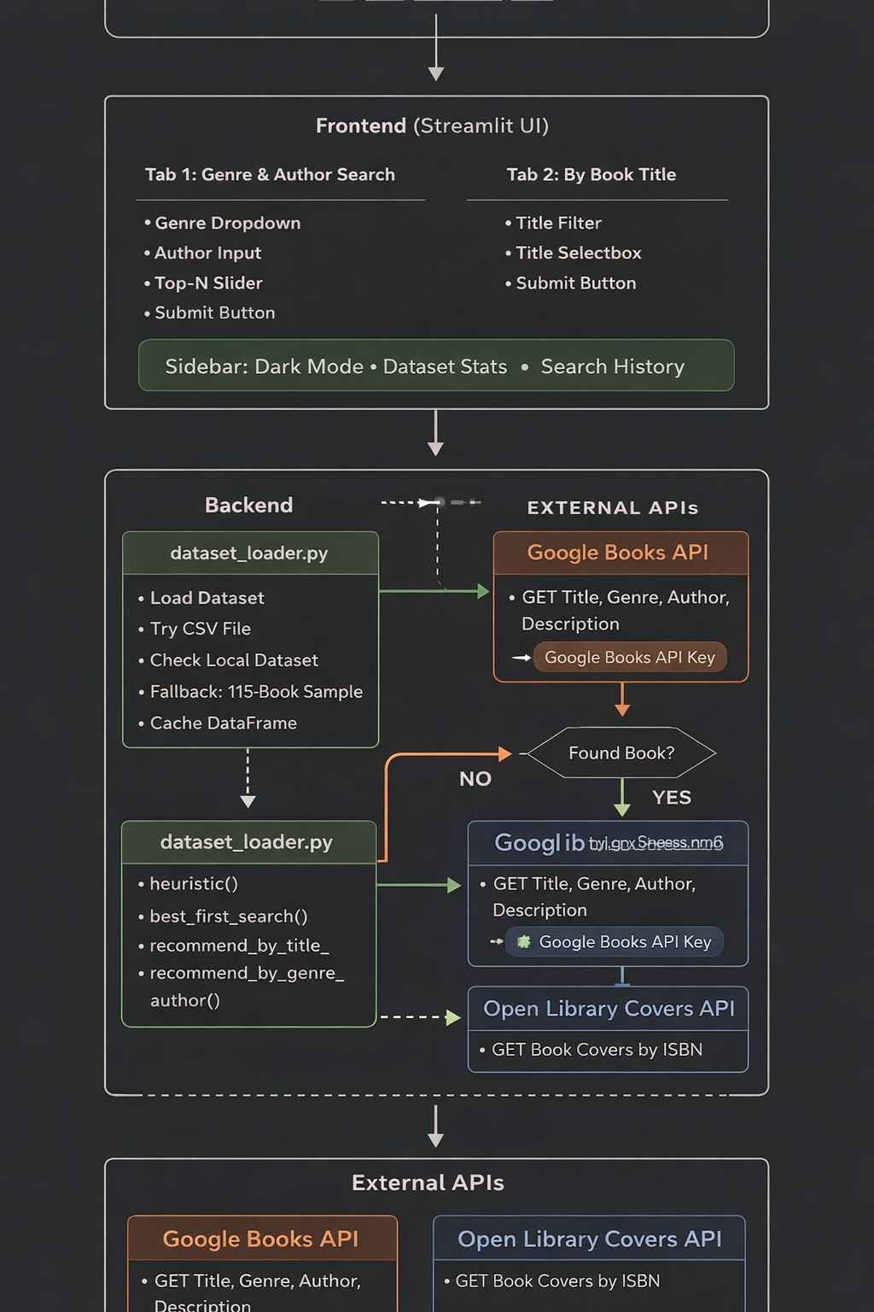
Caption:
This figure illustrates the architecture of the Smart Book Recommendation System, where the application first attempts to retrieve book data from the local dataset (built-in or CSV). If the required data is not found, the system dynamically fetches information using external APIs, including the Google Books API (via API key) and Open Library Covers API. The retrieved data is then processed by the recommendation engine using the Best-First Search algorithm to generate and display ranked book recommendations to the user.

3. Dataset Description and API Integration
3.1 Dataset Used
The system uses a hybrid data approach, combining:
1. Local Dataset
- A curated dataset containing 115 books across 14 genres
- Stored internally within the project
- Each record includes:
  - Title
  - Author
  - Genre
  - Rating
  - ISBN
  - Description
2. External Dataset (Optional)
- Supports GoodReads CSV dataset (up to 100,000 books)
- Automatically loaded if available
- Filtered for:
  - Rating ≥ 3.0
  - Valid metadata

3.2 Data Preprocessing
The dataset undergoes several preprocessing steps:
- Removal of null values
- Standardization of genre names
- Extraction of primary genre from multi-genre entries
- Limiting dataset size for performance
- Conversion into structured format (DataFrame)

3.3 API Integration
To enhance the system functionality, we have integrated:
Google Books API (API Key Used)
The Google Books API is used to:
- Fetch additional metadata
- Improve book information
- Provide dynamic search capability
Open Library Covers API
- Used to fetch book cover images using ISBN

The system combines dataset-based recommendations + API-based enhancements, ensuring both accuracy and real-time enrichment.

4. Model Description (Recommendation Logic)
The recommendation system follows a content-based filtering approach using:
- Genre similarity
- Author similarity
Each book is treated as a node, and the goal is to find the most relevant nodes based on user input.
The system does not rely on user history, making it:
- Lightweight
- Scalable
- Easy to interpret

5. Best-First Search Algorithm
Best-First Search is an informed search algorithm that selects the next node based on a heuristic value.
5.1 Heuristic Function
h(n)= 0.6× genre_match + 0.4 × author_match
Where:
- genre_match = 1 if genre matches, else 0
- author_match = 1 if author matches, else 0

5.2 Working of Algorithm
- Load dataset
- For each book:
  - Compute heuristic score
- Insert into priority queue
- Sort by highest score
- Return top-N recommendations

5.3 Priority Queue Logic
- Python uses a min-heap
- To simulate max behavior:
  - Scores are negated

5.4 Important Code Snippet
pq = queue.PriorityQueue()
for idx, row in df.iterrows():
score = heuristic(row['Genre'], row['Author'], pref_genre, pref_author)
pq.put((-score, idx, row.to_dict()))

5.5 Time Complexity
- Overall: O(N log N)
- Efficient even for large datasets

6. Modules Description with Important Code

6.1 data_loader.py
Purpose:
- Load dataset
- Preprocess data
Important Code:
def load_dataset(csv_path=None):
if csv_path:
df = pd.read_csv(csv_path)
else:
df = pd.DataFrame(SAMPLE_BOOKS)
df.dropna(inplace=True)
df = df[df['Rating'] >= 3.0]
return df

6.2 recommender.py
Purpose:
- Core recommendation logic
Code:
def heuristic(genre, author, pref_genre, pref_author):
genre_score = 1 if pref_genre.lower() in genre.lower() else 0
author_score = 1 if pref_author.lower() in author.lower() else 0
return 0.6 * genre_score + 0.4 * author_score
def best_first_search(df, pref_genre, pref_author, top_n):
pq = queue.PriorityQueue()
for idx, row in df.iterrows():
score = heuristic(row['Genre'], row['Author'], pref_genre, pref_author)
pq.put((-score, row.to_dict()))
results = []
for _ in range(top_n):
results.append(pq.get()[1])
return results

6.3 app.py
Purpose:
- User interface
- Interaction handling
Important Code:
genre = st.selectbox("Select Genre", genres)
author = st.text_input("Enter Author")
if st.button("Get Recommendations"):
results = recommend_by_genre_author(df, genre, author, top_n)

7. User Interface and Output

Figure 2 – Main Dashboard (Dark Mode)
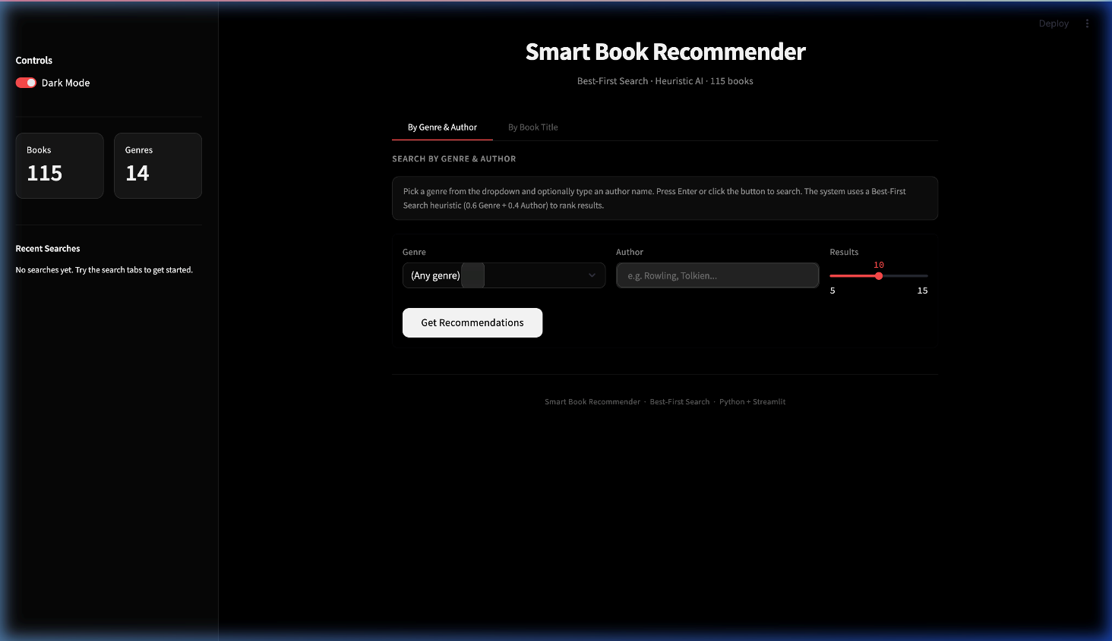
Caption:
Shows the main interface with dark theme, sidebar controls, dataset statistics, and search functionality.

Figure 3 – Light Mode Interface
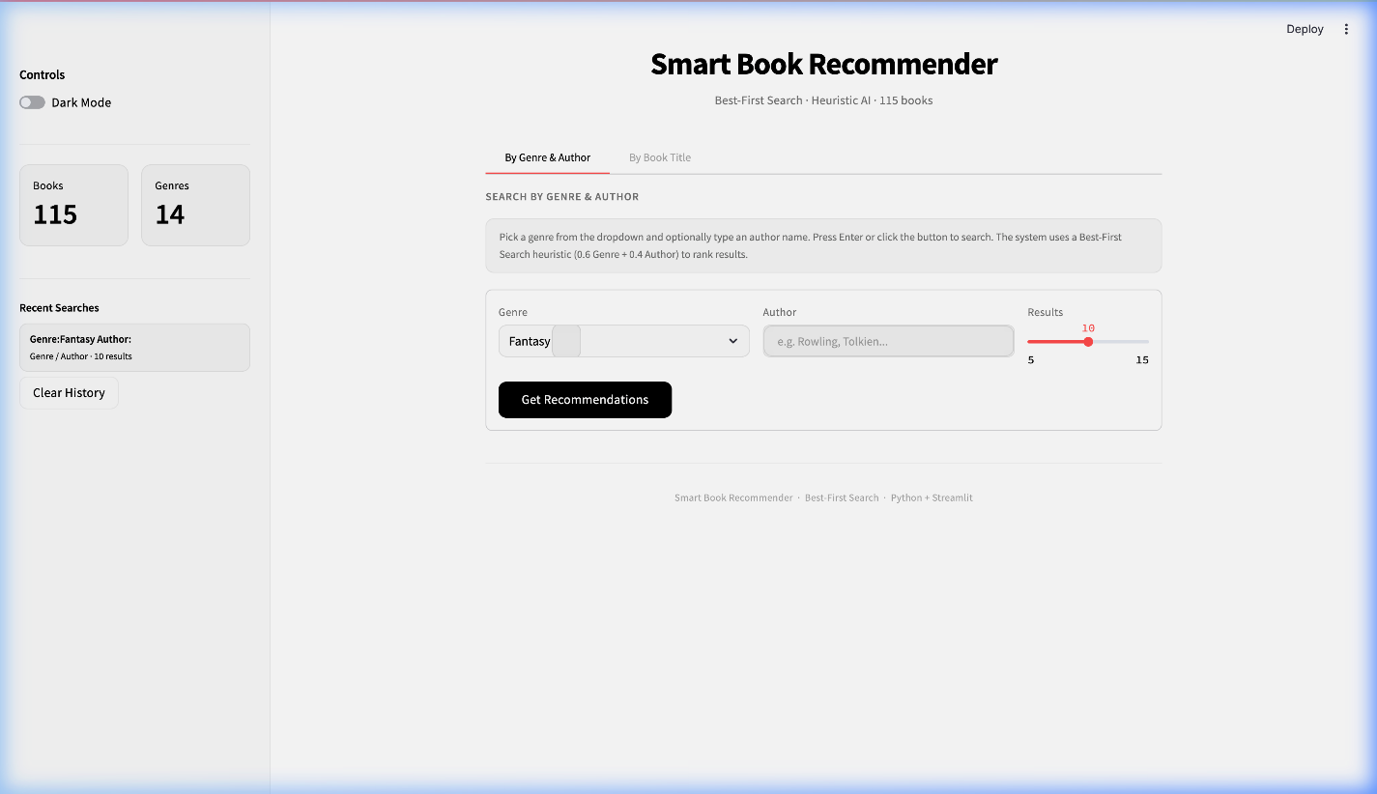
Caption:
Displays the application in light mode, providing a clean and readable interface.

Figure 4 – Title-Based Search Interface
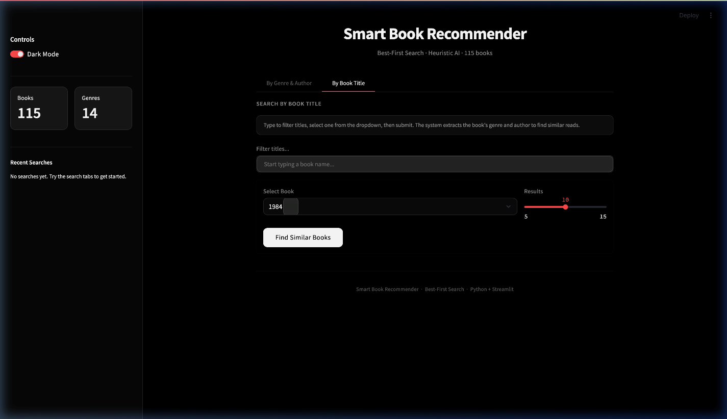
Caption:
Illustrates how users can search for a book title and receive similar book recommendations.

Figure 5 – Best Match Output
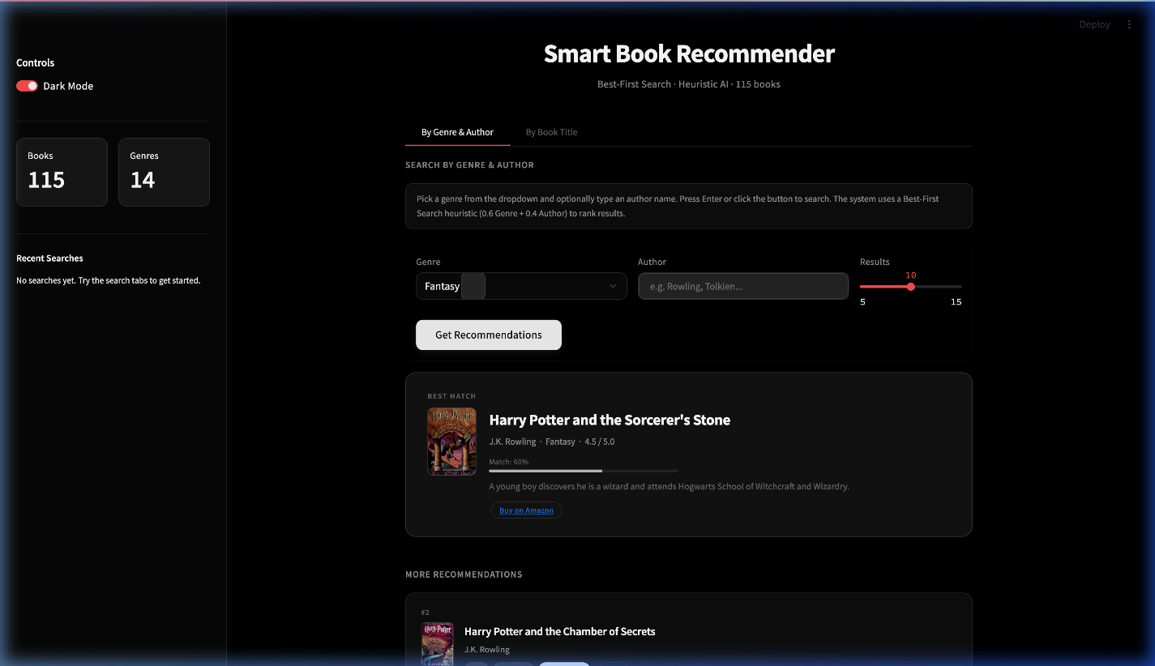
Caption:
Displays the top recommended book based on the highest similarity score.

Figure 6 – Recommendation Results List
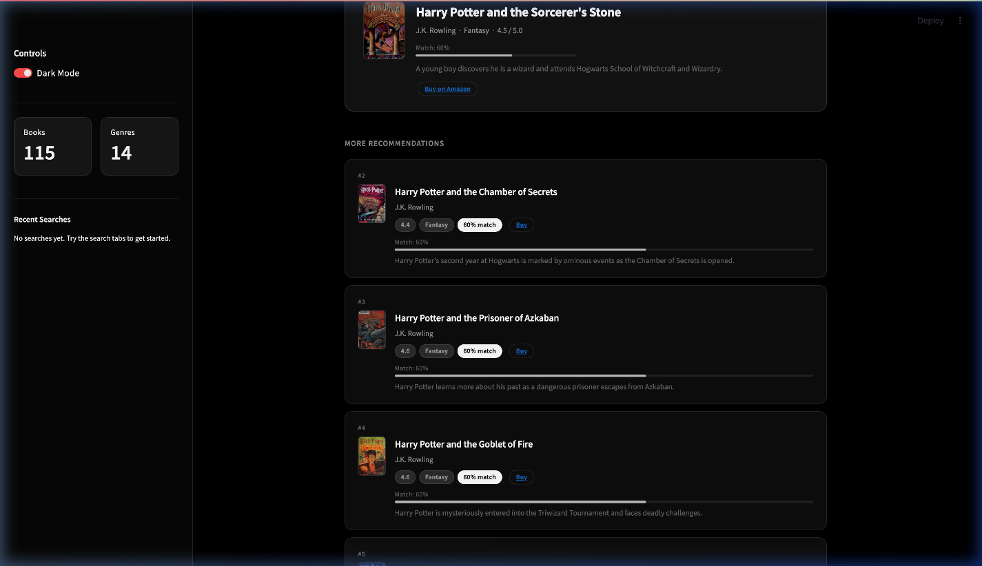
Caption:
Shows multiple recommended books ranked based on similarity score and relevance.

8. Results and Analysis
The system was tested using various inputs such as:
- Genre + Author
- Book Title
Observations:
- Books with same genre and author achieved highest scores
- Genre-based recommendations were most effective
- Title-based search successfully extracted features

9. Conclusion
The Smart Book Recommendation System successfully demonstrates the application of Artificial Intelligence using Best-First Search in solving a real-world problem.
Key achievements:
- Efficient recommendation using heuristic search
- Integration of both dataset and API (Google Books API)
- Real-time, user-friendly interface
- Explainable results using similarity scores
The system proves that even simple AI techniques can produce powerful and practical applications when combined with good design and structured data.

10. References
- Artificial Intelligence – Russell & Norvig
- Streamlit Documentation
- Google Books API Documentation
- Open Library API
- Pandas Documentation
- GoodReads Dataset

